*Line of Sight and Viewshed*

*Modeling Terrain Map Visibility from a Point*

Brayden Nicholl, Matthew Camarena, Shrinithi Kalai, Ye Lim Koo

Math 370

California State University, Fullerton

Fullerton, United States of America

[bradynicholl@csu.fullerton.edu](mailto:bradynicholl@csu.fullerton.edu)

[camarena.matthew@csu.fullerton.edu](mailto:camarena.matthew@csu.fullerton.edu)

shrinithi.kalai@csu.fullerton.edu

yelimkoo@csu.fullerton.edu

***Abstract*—A line of sight is the line created between two points, a viewer/observation point and a target/receiving point. All possible lines of sight from a given observation point combine to form a viewshed. Line of sight applications can be found across many disciplines and fields of society. For testing and theoretical purposes, viewsheds and their individual line of sight components can be calculated and visualized using software like MATLAB.**

# Line Of Sight

When we decided on how to solve for the line of sight problem, we wanted our model to be as simple as possible and then later we would work our way into a more complex model. To start off we defined what line of sight is, that being an unobstructed linear view from one point which we called a viewer point to another which we called the target point. To clarify, the line of sight must not be blocked anywhere between the two points, from viewer to target. The path between the two points must be linear, which means that it should follow the form y = mx + b in an -xy coordinate system, where b is an arbitrary constant and m is the slope of the line.

We started by graphing line of sight between two points the viewer and an object, in our case a pen. We can note that when we graphed the line of sight in [Fig. 1] on a 2-dimensional plane based off of something in the 3-dimensional world we are losing 1 dimension. This is possible because we are only required 2 dimensions to completely demonstrate a line. To solve this mathematically we would take one dimension as a constant, such that if we have the dimensions x, y, and z, we would set z constant such that the only axis left are x, and y, and such that the line of sight only requires x, and y to be represented. This is done by setting the axis appropriately such that the line of sight would only fall into the x,y plane, allowing us to set the z coordinate constant.

We needed to solve for an equation to represent the hand that blocked our line of sight. Since we decided that it must relate to terrain data, we figured that we would only have points at certain places and would have to resort to using interpolation to create an equation for the data. And once we interpolated the data, we were able to solve for whether or not there was an obstruction. We solved this by setting the two created equations equal to each other and solving for x. If any value x resulted from such was within the domain, which we set was all values x between the viewer and the target, then there was an obstructed line of sight.

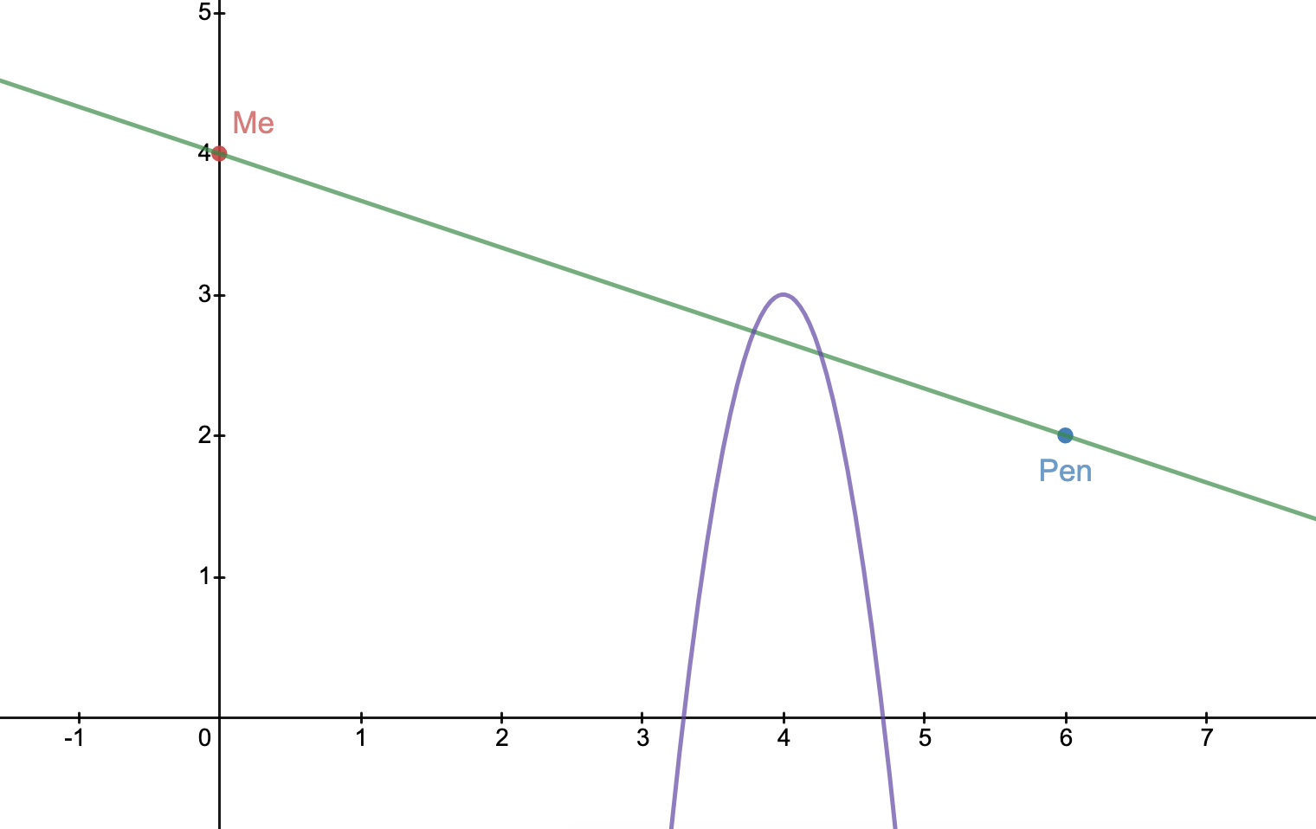

**Fig. 1**

We had to add a domain to our model of line of sight because of cases where terrain data might intersect with the line of sight, but after already reaching the target viewpoint. As we can see in [Fig. 2] the line intersects with the second equation but does not block the path from the viewpoint to the target point.

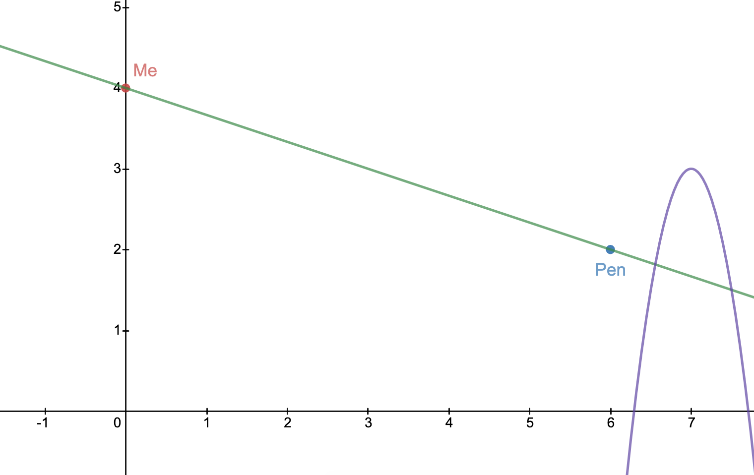

**Fig. 2**

We acknowledge the limitations of this model, such that interpolating data can be complex and time-consuming for real terrain data as well as containing to some degree error. As well as the line of sight might change depending on the type of sight we are dealing with, such as communications between two radio towers, where the data being transmitted would be sent in a wave manner, a line may not suffice to represent it and does not include interference.

# Viewshed

As mentioned in the earlier section, a line of sight is an unobstructed path between the observer and the point of interest. The line of sight can be represented by a straight line between two points, the first point being the observer point and the second being the target point. However, the line of sight is too simplistic when modelling terrain visibility, as it takes into account only one point of interest. A viewshed, on the other hand, includes all the points that share a line of sight with the observer point. Since a viewshed is a composite of all the lines of sight, it shows visibility from a specific point of a terrain. Points that are excluded from the viewshed are those that are obstructed and do not share a line of sight with the observer point, or points that are beyond the skyline.

Since we are shifting from a single line of sight to a more complex viewshed, it is important to establish several constrained variables while making a visibility map: *height*, *horizontal and vertical fields of view*, *azimuth*, and *pitch*. [1]

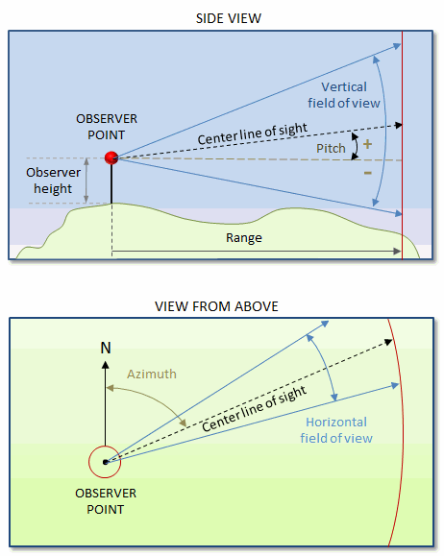

**Fig.3**

The figure above is a visual representation of the viewshed. The side view shows an observer on top of a hill, viewing a point of interest (which is represented as the center line of sight). *Height* refers to the height or elevation of the observer. The angle of view is measured horizontally and vertically with the *vertical* and *horizontal fields of view*. The *azimuth* is referred to as the angle measured between a reference point (i.e. North direction) and the center line of sight. The *pitch* is referred to as the angle measured between the center line of sight and the observer’s height. All these constrained variables are used in terrain analysis and construction of a viewshed model.

# Applications

Line of sight and viewshed is widely used in real-life applications. It is used when applications need clear line of sight, for example, used when building a house, cell tower, wind turbine, and weather radar. It is often used in the military as well. It is essential to use the line of sight in planning for these applications to save time, money, and to prevent misfortunate events.

For developers of a house or hotel, they want the best view from the window, so they used the line of sight to find the best location to place the window to get like the ocean view. Cell towers communicate by sending radio signals and send signals to our phone as well. Therefore, it is crucial to find the best height and distance of these towers. Also, the developers need to take considerations of the user’s location so that the users will have the best signal every time.

The wind turbine is cost-effective; it is renewable and is a clean source of fuel. The challenges that the wind turbine has would be that it needs a clear line of sight so that the wind can move the blades; if something were blocking the wind turbine, it would not work.

The weather radar is used to predict precipitation and severe weather conditions (tornadoes, thunderstorms, etc.). This radar is usually located in places that have severe weather conditions so that it predicts and can send our warnings to evacuate. The inaccuracy of this radar would cause life-threatening risks. This radar uses the radar’s Line of Sight to sends out transmitted Pulse of Electro-Magnetic Waves, and when it hits the water droplets, it will reflect and return to radar. The radar then collects this data by counting the time it took to get back so that it can predict how fast or the time for the weather condition to happen. Also, the strength of the signal will determine how strong precipitation.

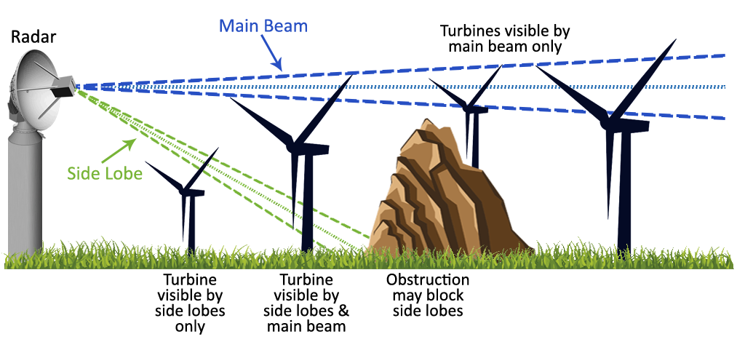

**Fig.4**

Depiction of how wind turbines affect weather radar

In Canada, wind turbines the blocked line of sight of the radar, created a dot in the area of the wind turbine. This resulted in not being able to go beyond the area of the wind turbine. This upset the residents that lived in this area because the radar could not predict severe weather like storms because the area is blocked. This decreases the accurate predictions and the safety of the residents.

In the military, the Line of Sight is used for the optimal position for battle. Also, it can be used in many methods, for example, The Tactical Line-of-Sight Optical Network (TALON). This TALON is used for communicating (sending voice or video) that uses the high-frequency lasers to more than 30 miles apart.

The radio Line of Sight is different from visual Line of sight because in real-life, there are impairments. The impairments include Fresnel Zone, Ground and water radio frequency reflections, Earth curvature, atmosphere, and 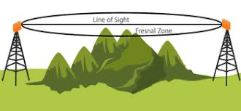

**Fig.5**

wireless obstructions.

In [Fig. 5] it displays the Fresnel Zone; this is an area that must be kept clear to get the maximum signal strength. If there is an obstruction, it will either decrease the signal or block the signal from transmitting. These signals have ground and water reflections, so the height would be significant for the signals to carry with max strength. To find the perfect height, online tools are available; for example, the Google Earth Pro has viewshed features that have a line of sight tool for developers to use. There are other online sources to find the maximum height to get the best line of sight to get the best signal possible.

The earth’s curvature affects the line of sight; therefore, it is best to keep the distance within seven miles (11265.4 meters). Also, the atmosphere affects the line of view because the signal does not travel at a uniform height above the earth. So, as the atmospheric pressure increases, the signal will be bent towards the earth and increase the propagation of about fifteen percent.

There are three types of wireless obstructions, smaller, same, and larger than the incident wavelength. If it is smaller, it does not cause any damage; if it is the same, it will slightly decrease the signal, and if it is larger, it will decrease dramatically or block the signal. The developers not only have to check for physical obstructions but have to check nonphysical as well before finalizing their location to use the radio line of sight.

# MATLAB Visualization

When modeling the lines of sight or viewsheds of an area, the elevations of the area are necessary. In MATLAB, a digital elevation model (.dem) file type was used for the terrain data. This file type gives a matrix of elevation values, and matrices of their corresponding latitudes and longitudes were created to make mapping possible. In this example, data of the northern Los Angeles Basin and the Angeles National Forest (latitude: 34 to 34.5, longitude: -118.5 to -118) was used. To begin, the terrain data was mapped in two dimensions as a starting point in visualizing the data [Fig. 6]. Using this map, an observation point was selected for later use.

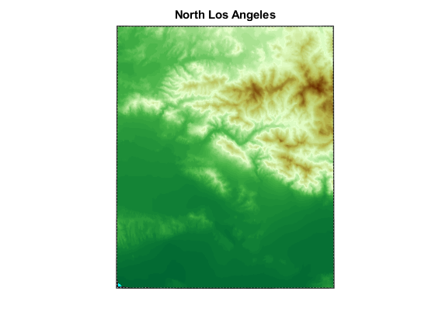

**Fig.6**

The terrain data was then modeled in three dimensions, so that the elevations were represented with actual changes in height as opposed to color [Fig. 7]. Using imagery from the United States Geological Survey, image data was draped over the model, adding realism and context to the map, and making interpretation easier from a visual perspective [Fig. 8]. The proper identification of man-made boundaries such as city limits and routes such as freeways was then possible due to the imagery being applied to the elevations.

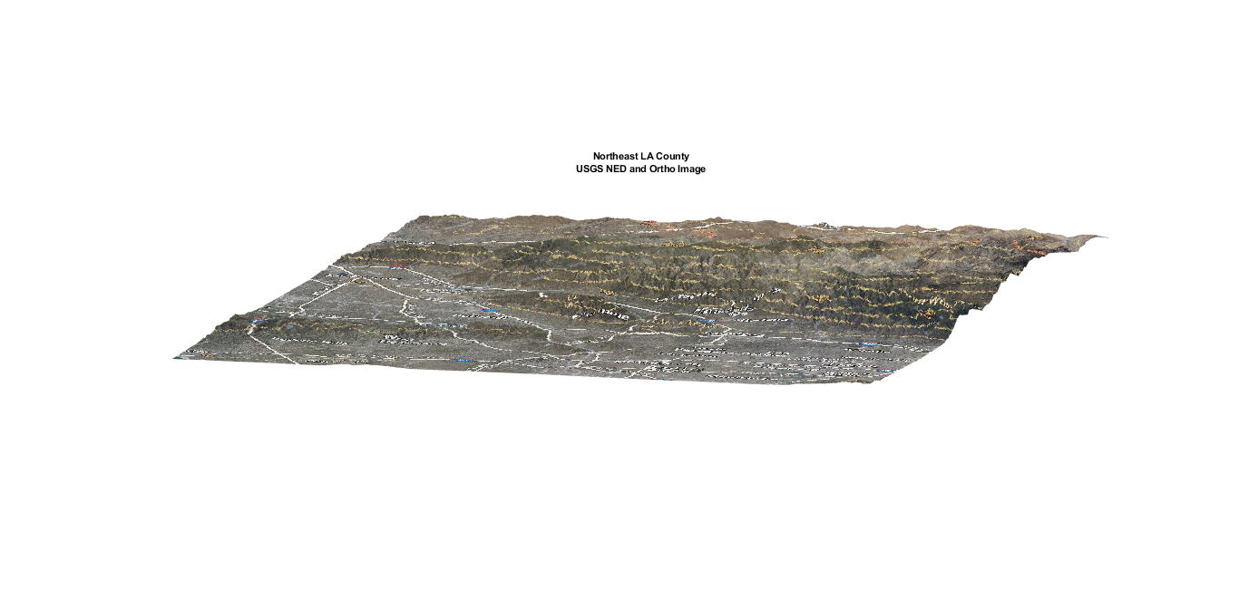

**Fig.7**

To construct a viewshed in MATLAB, the function viewshed() was used. This function takes as inputs the terrain data of an area, the coordinates of the observation point, and (optionally) the height above the observation point’s elevation the viewshed should be created from [6]. This allows for potential simulation of a viewshed for a tower of specified height at the observation point. The function outputs a reference vector for the viewshed points, and a matrix of 1s and 0s of equal size to the terrain elevations. Each entry represents the line of sight between the corresponding terrain data point and the observation point, with a 1 representing a clear line of sight, and a 0 an obstructed line of sight.

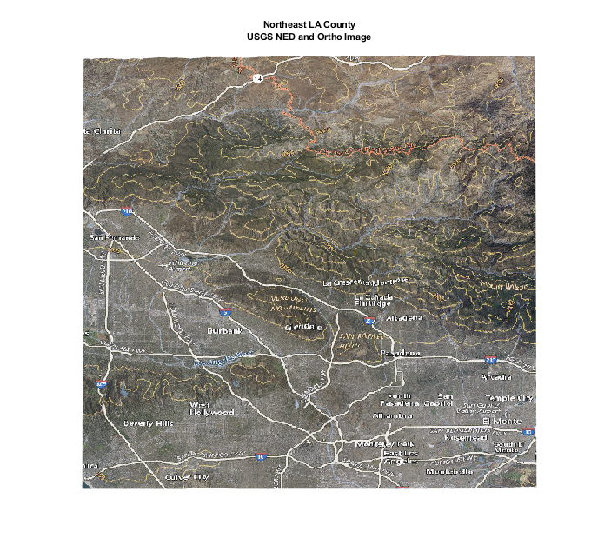

**Fig. 8**

Based on the two-dimensional terrain visualization, and the potential for real-world applications, the observation point chosen was (34.2267,-118.0658), also known as Mount Wilson, which is also the location of multiple major telecommunication towers servicing the greater Los Angeles area. After creating a viewshed based on a 100-meter-tall tower at this point, the color scheme of any point with an obstructed line of sight (therefore outside of the viewshed) was darkened, making the viewshed as a whole easy to identify visually [Fig. 9]. As could be expected, most of the populated areas of Los Angeles are within the theoretical tower’s viewshed. However, some areas, such as Burbank and Arcadia, lie almost completely outside of the viewshed, meaning that in reality these locations are probably serviced by subsidiary or alternative telecommunication towers.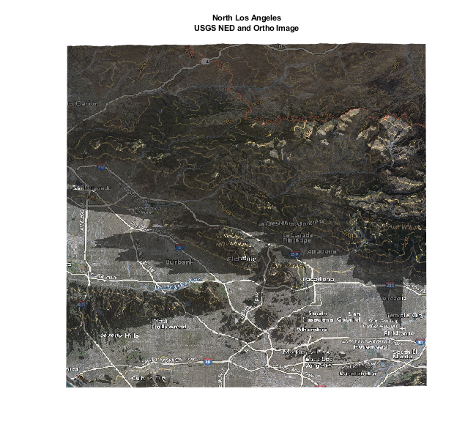

**Fig.9**

Fig. 9

This example creates a simulated viewshed based on elevations of the terrain, and nothing else. In reality, however, any object can potentially interfere with a line of sight, not just the ground.

# A Moving Reference Point

Since it is more or less linear in nature, a line of sight can be blocked by an obstruction anywhere along its path. These obstructions can be temporary, like storms or aircraft. Temporary obstructions tend to be relatively unavoidable or freak occurrences, and therefore are not actively worked on as problems that need solving. In contrast, the more concerning type of obstructions tend to be permanent objects, like a growing tree or a newly constructed building that blocks a previously clear line of sight. Because obstructions such as these will not move out of the blocked line of sight by themselves, work must be done in order to either make the original line of sight usable again (trimming back an overgrown tree) or changing the line of sight to a new, clear path (moving a television antenna away from a new building).

Each observation point has a unique viewshed, and therefore an observer’s viewshed would change if they were in motion. To help show this concept visually, the same observation point on Mount Wilson (34.2267,-118.0658) was used as a starting point. The observation point was then moved southwest across the map in 1/1200 degree (approximately 20 meter) increments, and a viewshed was calculated for the point after each movement. In this specific case, as the observation point moves southwest, its elevation decreases, which in turn causes many lines of sight to be blocked, shrinking the overall size of the viewshed [Fig. 10].

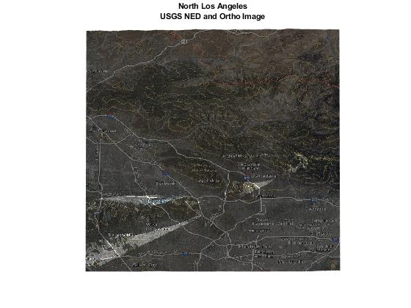

**Fig. 10**

# Acknowledgment

We are very grateful for Dr. Charles Lee for giving us the opportunity to research and work with such an interesting and applicable topic.

# References

1. Izraelevitz, D. "A Fast Algorithm for Approximate Viewshed Computation." Photogrammetric Engineering & Remote Sensing 69, No. 7 (2003): 767-774.
2. “Laser-Based Communications Passes Military Tests | light speed ...”. [Online]. Available: https://www.photonics.com/Articles/Laser-Based_Communications_Passes_Military_Tests/a55391.
3. “Advantages and Challenges of Wind Energy,” Energy.gov. [Online].Available: https://www.energy.gov/eere/wind/advantages-and-challenges-wind-energy.
4. F. of T. Hurons, “Overview of wind turbine interference with weather radar,” *Save The Huron Mountains*, 02-Oct-2018. [Online]. Available: https://savethehuronmountains.org/2018/09/14/overview-of-wind-turbine-interference-with-weather-radar/.
5. Wpengine, “Wireless line-of-sight, non-line-of-sight, beyond-line-of-sight propagation,” *Control Engineering*, 11-Sep-2018. [Online]. Available: https://www.controleng.com/articles/wireless-line-of-sight-non-line-of-sight-beyond-line-of-sight-propagation/.
6. MathWorks, “viewshed,” *Areas visible from point on terrain elevation grid - MATLAB*. [Online]. Available: https://www.mathworks.com/help/map/ref/viewshed.html.